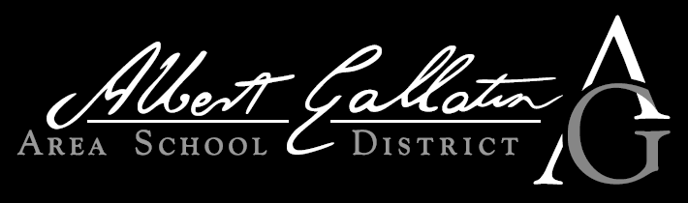

Colonial Online Learning Academy

COLA

2020 – 2021

Student Handbook

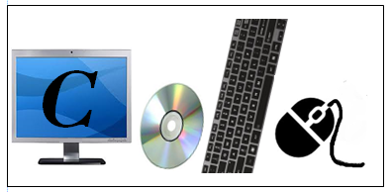



**COLA Administration and Support Team:**

Superintendent

**Mr. Christopher Pegg**

724–564–7190 ext. 8119

christopher.pegg@agasd.org

Assistant Superintendent

**Dr. Jason Hutchinson**

724–564–7190 ext. 8121

Jason.Hutchinson@agasd.org

Federal Coordinator/Elementary Supervisor

**Mrs. Lara Bezjak**

724–564–7190 ext. 8134  
lara.bezjak@agasd.org

Special Education Director

**Mr. Jared Plisko**

724-564-7190 ext. 8114

jared.plisko@agasd.org

Attendance Director

**Mr. Gary Serock**

724–564–2024 ext 5404

Gary.Serock@albertgallatin.k12.pa.us

COLA Coordinator

**Mrs. AnneMarie Koss**

724–564–2024 ext 2226

akoss@agasd.org

**Technology Help Desk (Technology Issues)**

**Mr. Chris Bolin**

tech.help@agasd.org

**Edgenuity**

Edgenuity’s Virtual Classroom is designed for students in grades 5 through 12. Edgenuity is a third party curriculum developer who has created large databases of lessons, assignments, and assessments that correspond to the same state standards & objectives as the students in the traditional classroom. AGASD teachers are the individuals who grade all the subjective assignments and interact with the students. Using Edgenuity gives students the flexibility to complete their course work anytime, 24 hours a day, seven days a week.

**Student** **Access/Course** **Work**

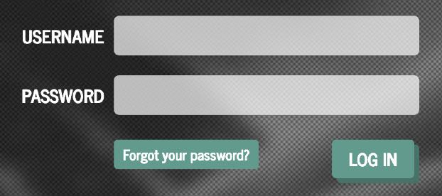Upon enrollment a letter is sent out to the parent and student with the credentials necessary to log into the system. The Internet address to access courses is:

**http://learn.edgenuity.com/student/**

Once you type the web address into the address bar of your Internet browser you will be taken to the Virtual Classroom login page. Use the information on your welcome letter to enter the site.

**Monitoring** **Progress**

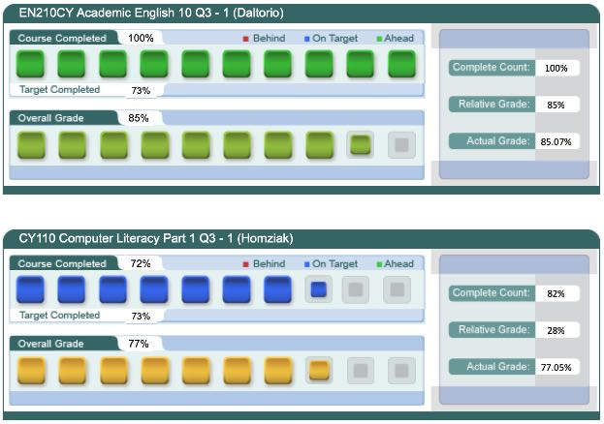Students, parents, and teachers have access to several resources to monitor grades and ensure an appropriate pace is being maintained to complete each course in the allotted amount of time. The progress report is one of these resources. This report provides visuals and percentages to illustrate the student’s current pace and grade. Students automatically have access to these reports, parents can receive email notifications with progress reports or sign up to use the Edgenuity Family Portal where parents can access the progress reports at any time.















